8051 i2c (bit banging) code + Proteus simulation
This post provides the i2c bit banging code for 8051 (e-g for AT89C51 or AT89C52 etc) microcontroller. As we know^{[1]}, 8051 microcontroller doesn't have any built in i2c modules, so we have to create it in the software. This code is written in C language using Keil uvision4 compiler. You can download this code from the 'Downloads' section at the bottom of this page.
It is assumed that you know how to blink an LED with 8051 microcontroller. If you don't then please read this page first, before proceeding with this article. It is also assumed that you know how i2c protocol works, if you don't then please read this page first.
The result of simulating the code in Proteus is shown below.
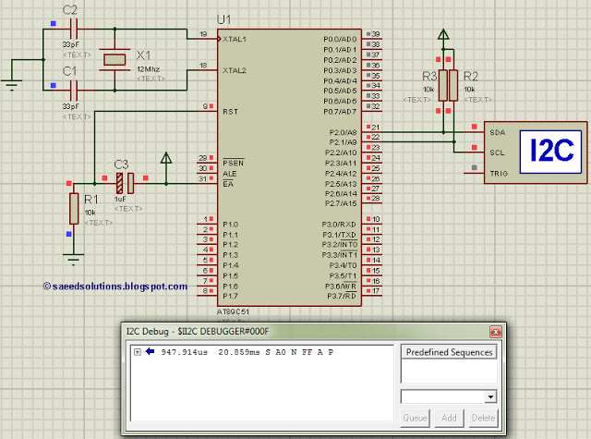
Figure 1. I2C testing circuit for PIC16F84A
In the above circuit^{[2]}, P2.0 pin is being used as SDA pin and P2.1 pin is the SCK pin. Both of these pins are pulled up using 10K resistors as required for i2c protocol. Proteus provides an 'I2C Debugger Tool' which is attached on the SDA and SCK pins in the above circuit. This i2c debugger tool receives all the i2c messages and displays them on the 'I2C Debug' window displayed in above figure. Close up image of this 'I2C Debug' window is shown below in the figure.
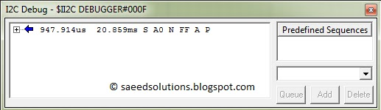
Figure 2. I2C Debug window
In the above figure, 'I2C Debugger Tool' is telling us that first of all it received i2c start bit S. Then a value of 0xA0 was received. After that, there was a NACK bit (named as N in the above figure). After the NACK, a value of 0xFF was there on i2c bus. After that, an ACK was there (named as A) in the above figure, and in the end i2c stop bit (named as P) was received. When this Proteus simulation started then after 947.914usec 8051 started sending this i2c data and stopped at 20.859msec time.

Code
The code for the main function is shown below.
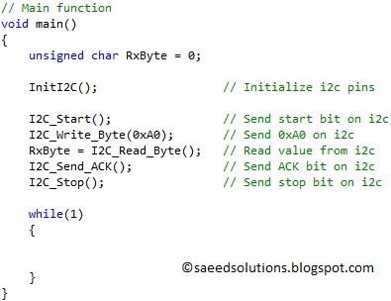
Figure 3. Main function code for i2c code for PIC16F84A
In the main function, firstly i2c pins are initialized using InitI2C() function. Then I2C_Start() function sends a start bit S on i2c bus. Then a value of 0xA0 is written on the i2c bus using I2C_Write_Byte(0xA0); statement. After that, I2C_Read_Byte() function reads a byte from the i2c bus, because there is no slave attached on the i2c bus, that is why RxByte will receive a value of 0xFF^{[3]}. After that, an ACK 'A' is transmitted on i2c bus using I2C_Send_ACK() function. And in the end a stop bit 'P' is transmitted on i2c bus using I2C_Stop() function.
You can compare this main function code with Figure 2. Where i2c debugger is telling us that a pattern of "S A0 N FF A P" was received, but here in the main code we are sending "S A0 FF A P". There is a NACK missing. The reason for this is that, I2C_Write_Byte() function is written in such a way that it writes 8 bits on the i2c bus and then reads a single bit ( ACK or NACK ) from i2c bus^{[4]}. Because there is no slave attached on the i2c bus at the moment, that is why I2C_Write_Byte() function reads a NACK bit^{[5]}. So, this concludes that 8051 is actually writing "S A0 N FF A P" pattern on i2c bus as confirmed by Figure 2.
The code used to set different properties of i2c bus is shown below. (From I2C.h file)
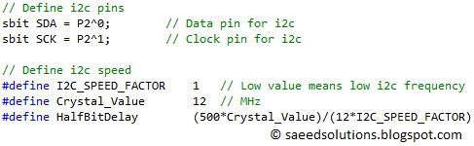
Figure 4. i2c properties selected in the code
In the above figure, SDA pin is selected to be P2.0 and SCK pin to be P2.1. You can change these pins if you want. Also, I2C_SPEED_FACTOR is defined to be 1. When value of I2C_SPEED_FACTOR is increased, then i2c clock rate will also increase. If a lower crystal value is used then you should use lower value of i2c speed factor as well to avoid errors. Crystal_Value is defined to be 12, because 12MHz crystal is attached with 8051 in the circuit. If any other crystal is used with 8051 in the circuit, then you should correct this Crystal_Value in the code as well. For example, if a crystal of 24MHz is used with 8051, then Crystal_Value should be defined to be 24. HalfBitDelay value is always equal to (500*Crsytal_Value)/(12*I2C_SPEED_FACTOR).
InitI2C() function code is shown below.
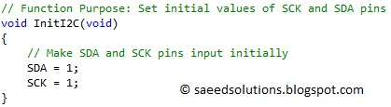
Figure 5. InitI2C function code
In InitI2C() function, firstly SDA and SCK pins are made inputs by making there value high. The code for I2C_Start() function is shown below.
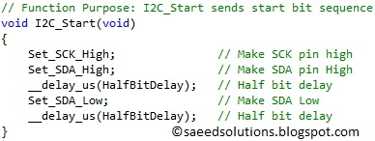
Figure 6. I2C_Start function code
In I2C_Start() function, firstly SDA and SCK both pins are made high. Then after HalfBitDelay SDA pin is made low, keeping SCK pin high, this generates the start bit 'S'.
The code for I2C_Write_Byte() function is shown below.
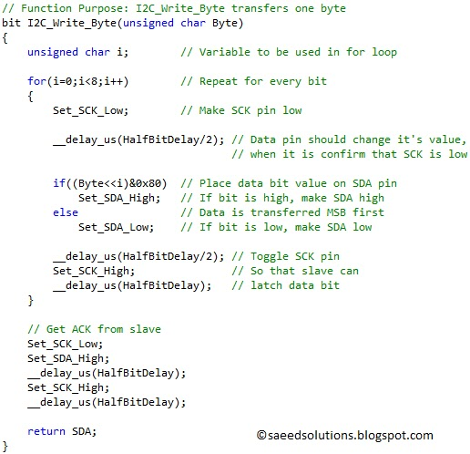
Figure 7. I2C_Write_Byte function code
In I2C_Write_Byte() function, using a for loop which repeats for 8 times, each bit of the variable Byte is transferred on i2c bus. Data is transmitted MSB first. SCK is made low, then correct data bit value is placed on SDA pin and then SCK pin is made high so that slave can pick this data bit value on the rising edge. In the end of the function, a clock pulse is sent to the slave to receive ACK or NACK from it. If slave makes SDA pin low, then it is an ACK, otherwise it is a NACK. Status of SDA pin (ACK or NACK) is returned from the function.
The code for I2C_Read_Byte() function is shown below.
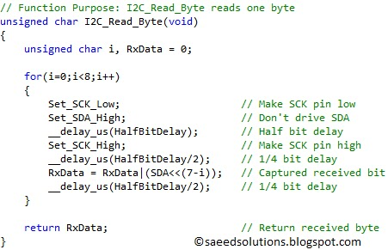
Figure 8. I2C_Read_Byte function code
In I2C_Read_Byte() function, 8 clock pulses are transmitted to the slave. Slave places the data on each clock pulse, this data value is saved in the RxData variable. This variable is returned from the function in the end. Data is received in MSB first style.
This is just an example code of how to use this i2c code library. For a more comprehensive example of how to use this i2c code library, you can check "Interfacing of 8051 with (i2c based) 24LC64 EEPROM" post.
You can leave your comments and suggestions in the comment section below.

Notes and References
^{[1]} From the datasheet of 8051.
^{[2]} In this circuit, 8051 is running at 1 MIPS speed using 12 MHz crystal.
^{[3]} Because SDA pin is pulled up normally and when 8051 is not driving it, then it will always stay high because of the pull up. That is why when there is no slave, then a value of 0xFF will be read.
^{[4]} This is because mostly slaves generate an ACK or NACK after every byte they receive. So, I2C_Write_Byte() function is written in such a way that it transmits a byte to slave then receives ACK or NACK and returns this received bit.
^{[5]} When there is no slave on i2c bus, then SDA pin will always stay high when 8051 is not driving it. And when 8051 gives a pulse on SCK pin to read ACK or NACK bit, then because SDA pin will be high then it will be interpreted as NACK.

